James Sanderson, Director of Personalised Care at NHS England and NHS Improvement and Chief Executive of the National Academy for Social Prescribing (NASP)
_______________________________________
JAMES SANDERSON is the Director of Personalised Care at NHS England and NHS Improvement where he leads on a range of programmes that are supporting people to have greater choice and control over their health and wellbeing. James also became the CEO to the National Academy for Social Prescribing (NASP) in 2019 where James leads on creating partnerships, across the arts, health, sports, leisure, and the natural environment, alongside other aspects of our lives, to promote health and wellbeing at a national and local level. View the NASP strategy here. James joined NHS England in November 2015 and was formerly the Chief Executive and Accounting Officer for the Independent Living Fund (ILF). The ILF was an arm’s length body of the Department for Work and Pensions and supported disabled people across the whole of the UK to live independent lives through the provision of direct payments enabling the purchase of personal assistance support. Prior to joining the ILF in 2002, James had a career in the motor industry within a number of sales and marketing roles, in both corporate and retail environments. James is a performing arts graduate with a background in community theatre.
It is real privilege to follow Keith, and to hear his amazing journey, and his passion for the arts. I want to say a little about the wider context. Looking at the agenda there are so many amazing speakers, people that have inspired me, and who have worked very closely with me, really developing SP into the force for good that it is within the health sector today. I want to start by paying tribute to Veronica, for all the work that you have done, raising the profile of the arts as a tool to support people with dementia in ways that we could only have imagined a few years ago.
To begin, I will start in 4000 BC for a potted history in health care, because there is so many speakers talking about the specifics of arts and nature, and support for people living with dementia, looking at the science and the evidence – it is great to see Helen on the agenda to talk about the real scientific evidence behind it. I thought I would take a broader context and say why this is important I think we are in a third revolution in healthcare, if you look at big waves of health and care that starts around 4000BC in Babylon, which is really the start of civilisation, their credited with developing the first forms of sanitation and clean running water. That advancement in health was one of the biggest health advancements that society made. Then not much really happened until nineteenth- and twentieth- centuries. If you look at the big steps in health, we did not really do a lot as a society, but there was huge acceleration of health and medication during nineteenth- and twentieth- century. We had the discovery of antibiotics, the opportunity of immunisation in society for the first time, and we had also the development of modern medicine, surgical techniques for the first time. If you consider history, we went very quickly from discovering antibiotics, to being able to transplant hearts, lungs and all sorts of amazing advancements, but actually, we are seeing now that medicine has limitations.
Biomedicine is brilliant, we still love the drugs, and in the context of seeing the amazing power of science and biomedicine over the past few months with the rollout for the vaccine of COVID19, we are still seeing the significant benefits that biomedicine has in society. However, we are also seeing the pitfalls. Resistance to antibiotics creates issues, we are seeing addiction to opiates creating issues. NICE published new findings (7 April 2021) which said that actually, it was better to prescribe exercise rather than long term painkiller medications for people living with chronic pain. Now that is a significant shift in the way in which we deliver health care support. This shift has been happening for some time.
This third revolution, the realisation that what makes us well is not what happens in the hospital. Clinicians do an amazing job every day of the week, but most of our life is not spent in hospitals or general practices, even for those of us living with significant long-term conditions. Our lives are spent in society. We know because of social determinants of health, the environment around us determines how healthy our lives are. We are also seeing gross inequalities, in certain cities for example, along single bus route you can see a life expectancy reduce by 10-15 years. That is an incredible situation to be in as a developed society with a health care system as sophisticated as ours. We need to do better. Doing better is engaging with the person. As Keith has demonstrated, clinicians are experts in diseases, but people are experts on themselves. We are experts in the individual, we know what works, and actually as human beings we recognise that some of those things that we’re experiencing in life will not make us well, and some things will help us achieve the goals we are hoping to achieve. How do we tap into that experience? This knowledge people bring to their own care, that’s where personalised care comes in.
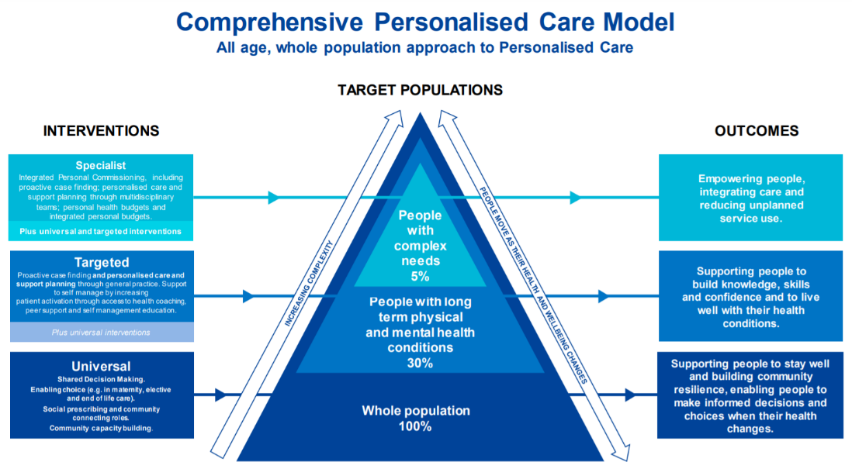
In 2018 we launched our Comprehensive Model for Personalised Care. In 2019 we published Universal Personalised Care: Implementing the Comprehensive Model. Universal personalised care is a blueprint for a new model of NHS care and support. Personalised care means giving people choice and control over the way their care is planned and delivered, based on their skills knowledge and confidence, and the assets they bring to their own care. That is a simple premise but is a significant shift in the way we deliver healthcare. Engaging with individual, making sure we are delivering services that are not a one size fits all service, but a one size fits one service, which is the way in which we are embracing this third revolution in health.
The comprehensive model for personalised care that was implemented in 2019, is now a core part of NHS, and is a model which all of the Integrated Care System (ICS) are going to have to deliver as part of structure for the NHS. That is a massive advancement. There are six elements in this, it starts on the basis of shared decision making, engaging people with simple questions, what matters to you. Not starting with what is wrong with you, not starting with diagnosis, but looking at what matters to you, the person you are. That starts a conversation that breaks down barriers for the individual and the conditions that they are living with. The siloed approach in health is not relevant in society now. We have tended to assume that they have mental health issues on a Tuesday and cancer on a Sunday. We do not see individuals as living with those things at the same time. As complex human beings all of that is going on at any one time.
So, starting with shared decision making, then moving onto giving people choice. That is meaningful to them. We see this in relation to medications, if you give people the real information and evidence around the certain risks and benefits to medication or treatments, you tend to see a reduction of 20% of people choosing the most costly treatments in society, Universal Personalised Care: Implementing the Comprehensive Model (2019). It starts by engaging people with a different conversation, where you can transform the way in which services are delivered. For people living with long term conditions, we need a care plan, a personalised care and support plan that look holistically at their lives, that enables them to talk about not just their conditions, symptoms, but the challenges that they are facing in life. That is how we start to tackle health inequalities, because we can begin to engage on those social factors, that are perhaps creating barriers to people achieving a good life. It is not right to talk to someone about diet or exercise if they are living in circumstances where they can’t afford food or electricity or can’t afford a pair of trainers to go out and do the park run. We have got to look at the individual behind the condition.
Beyond that, what we set was three key things that are going to define how we support people going forward. One of those things was SP; the opportunity to engage people with community-based activities. Many people have the ability to connect themselves, but many people need support, and that is why we have committed to the SPLW role. I know that there are a number attending the conference today, and I want to pay tribute to the work SPLW have done, especially alongside challenges of the pandemic, I know you have worked tirelessly to support people in your communities, and we are immensely grateful. We have got about 1800 SPLW in post across the country, but the NHS committed to implement 4500 SPLW over next few years. That is a new work force that will work alongside health coaches, and care navigators that will form round 7500 people in the NHS, who will be dedicated to delivering this sort of personalised care. The SPLW investment alone is a £450 million. worth of government investment. We are the first health economy in the world to implement support for psychosocial community-based activity, alongside biomedicine. This is a huge advancement for a health system.
I completely understand Keith’s point that we haven’t yet got universal system up and running. We still have pockets of the country that aren’t benefiting from these types of support, but determination, the funding and the mechanism to do that, so there is genuinely a universal system, is there. We want SP to work across the four zones of SP, so all of the activities that we talk about today are embracing arts, culture, whether that is singing for the brain, dance, music, we want art and culture to be part of it. We also need to support people to exercise, and to engage in sports, whether that’s walking football or ramblers’ associations. We want people to engage in nature-based activities, green SP. We have just funded a £4.5 million programme to enhance green SP across seven areas of the country. Blue SP is also becoming increasingly popular, with people engaging with open water swimming.
The fourth zone is knowledge. We want people to have the skills, knowledge and confidence, and to have the wisdom to be able to live with their long-term condition. If someone is newly diagnosed, why are we not making them an expert in that condition, why are we not supporting them to be as highly educated as they can with understanding around how that condition will affect them. The other two aspects are support for self-management, linking to peers already living with that condition and building the confidence. We know that those people with least skills, knowledge and confidence around their health are less likely to deliver the outcomes they are seeking to achieve. If we can shift someone from least confident to most confident, and we can measure that, the evidence points to 19% reduction in GP attendance, and a 38% reduction in hospital admissions, just by ensuring people have the right skills and knowledge, Reducing emergency admissions: Unlocking the potential of people to better manage their long-term conditions (2018).
Finally, personal budgets. The opportunity for people living with dementia to have a personal budget to be able to support themselves in a meaningful way, to be able to structure their care package that most matters to them, and to be able to engage in innovative ways of supporting themselves. To round up, personalised care is a blueprint for how we change the system. I think it is a new revolution, within that SP is one of the most powerful tools we have got to embrace supporting people in the system. I am really grateful for everyone who is speaking today on aspects of how we can make that happen. All of the tools are there, all of the programmes are there, the funding is there from government, and structure is in place. We have just got to work together to make this happen now.
Contact: danielle.wood2@nhs.net

